Name: Justin V Kalappura
Roll No: 10
Batch: B
Date:09/05/2022

NETWORKING & SYSTEM ADMINISTRATION LAB

Experiment No.: 20

Aim
Check whether a year is leap year or not.

Procedure
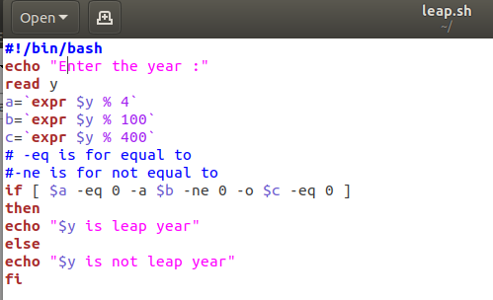

Output Screenshot
